TimeWielder, the task manager app for students with ADHD

## Team Bubbles

Nate Roberts - Project Manager

Aspyn Call - Designer

Danny McA’Nulty - Developer

Jackson Cyr - Developer

# Problem

With the explosion of technology and social media in the modern world, there are more ways than ever for students with inattentive disorders to become distracted and fail to finish their school tasks on time, resulting in mental stress which can snowball into mental health issues. For example, attempting to complete assignments, far too often notifications from phones can provide an easy way to leave an assignment for long enough that it's never returned to. While there are many task management software out there, the major free ones like Trello are designed for neurotypical people and more specialized software is trapped behind a paywall and does nothing to limit notifications themselves. How might we create a free app that will reduce the amount of notifications students see and create a system that will check in frequently to make sure tasks are being completed.

# Prior Solutions

## Motion

Motion is a calendar and planner app that uses AI to sort tasks and events by priority. It also builds a schedule for you that will ultimately save you up to 30 days per year.

Even though this app has been the next best thing for people with ADHD, its features are blocked by a paywall. In contrast to this, TimeWielder will be free to use.

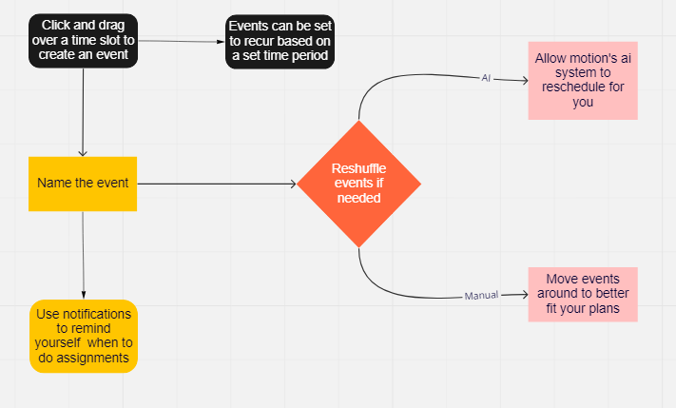

## Trello

Trello is a web application used for organizing your life and projects with Kanban-style boards which break each project into upcoming, in progress, and completed tasks. With the collaborative features Trello offers you can add other users to your boards and work together on tasks entered on cards. With powerful tools like planning automation and options to connect other services to your boards you can complete tasks more efficiently.

Unlike Trello, TimeWielder will focus on the needs of ADHD students and help keep them on task without getting overwhelmed. TimeWielder will also be free to use without any features locked behind monthly subscriptions.

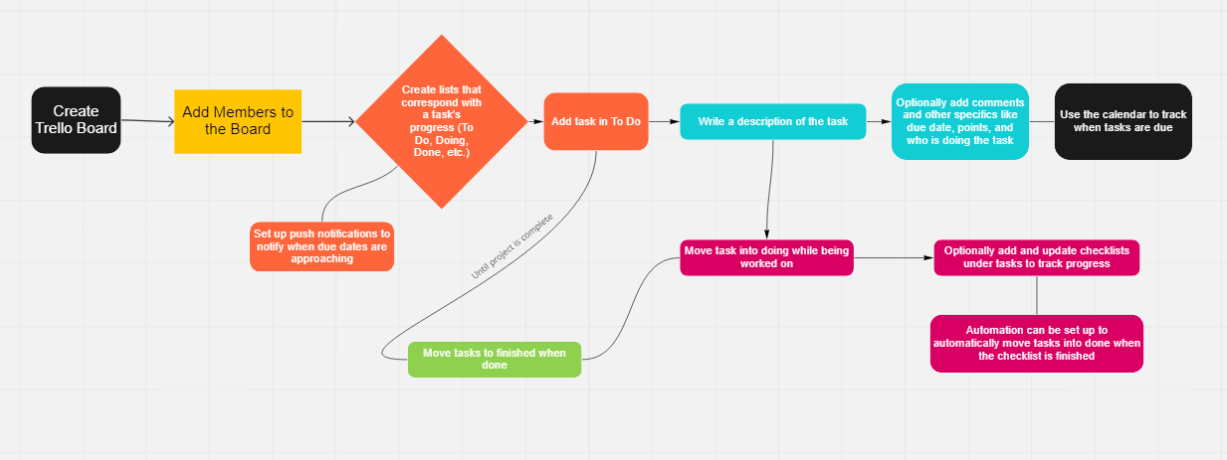

## Todoist

Todoist is a task management app that is used to help complete large projects, or just to manage your everyday workload. You can create projects in order to achieve your goals, big or small. Under that project you can add tasks to plan your project, and you can then add sub-tasks to make the tasks more manageable. You can set the due dates for these tasks and sub-tasks in order to stay on track, and can even color code the tasks to prioritize certain tasks over others.

Todoist is a good task management app that isn’t stuck behind a paywall, but it doesn’t help those with ADHD remain on task. TimeWielder will be a free app with push notifications to help keep users on task.

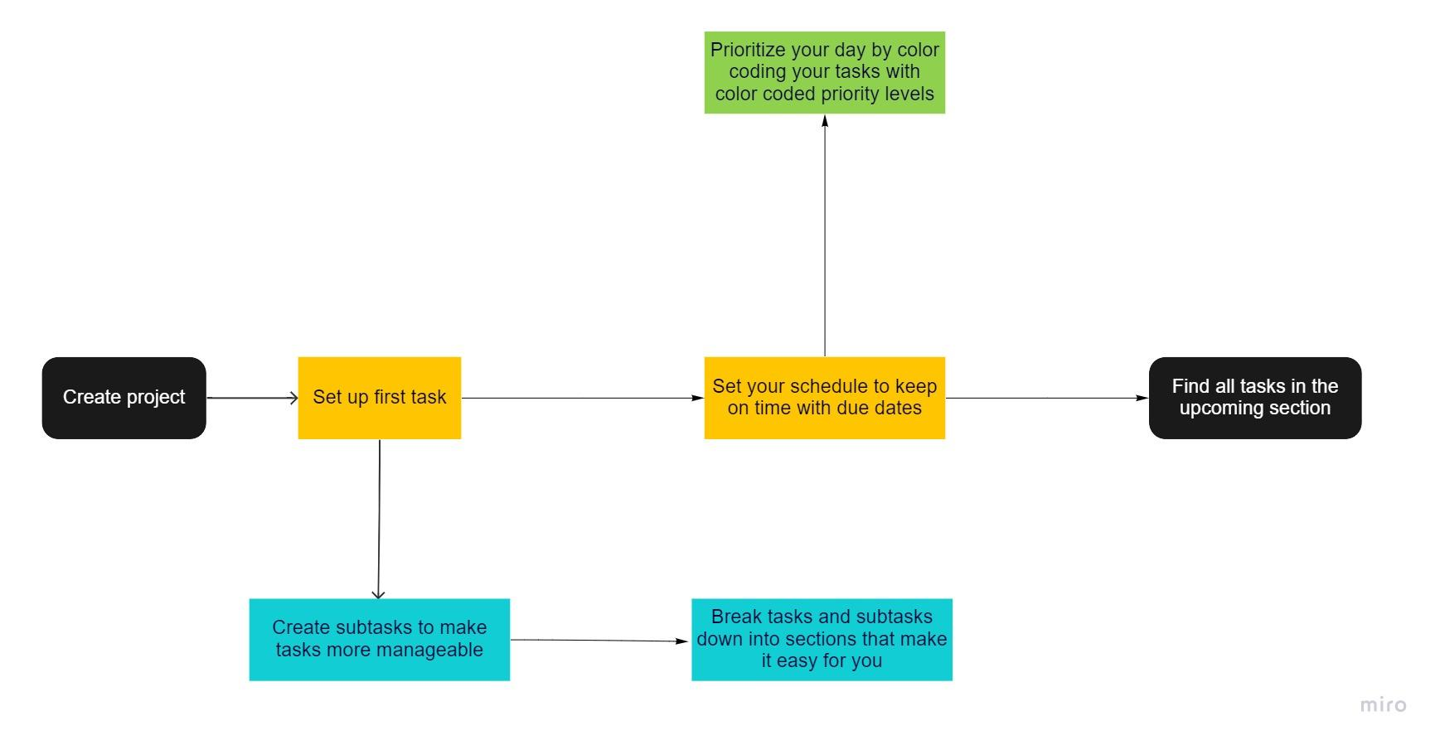

# TimeWielder

**A summary paragraph describing the functionality/tasks that YourApp will provide, (which is provided in more detail in the following paragraphs)**

TimeWielder is a task management application that is specifically targeted towards students with ADHD and other inattentive disorders. The app will be centered around two major elements. The first is a calendar where users can plan out their tasks, assignments, and/or exams. The second is a kanban that will allow users to keep track of task completion progress. The calendar will also allow people to set aside periods of time to be dedicated to working on a certain task. The app can be set to remind users of upcoming work periods/due dates by leveraging push notifications to a set email or sms number. The app should also be able to limit notifications sent to the user by leveraging do not disturb functionality on the users device should the user want it to. The kanban board will allow users to track the progress of the tasks that are set on the calendar.

**A task flow diagram for YourApp. This does not need to be exhaustive, but should cover the major functionality of the application. Provide a link to the diagram that has commenting/edit privileges for the instructor.**

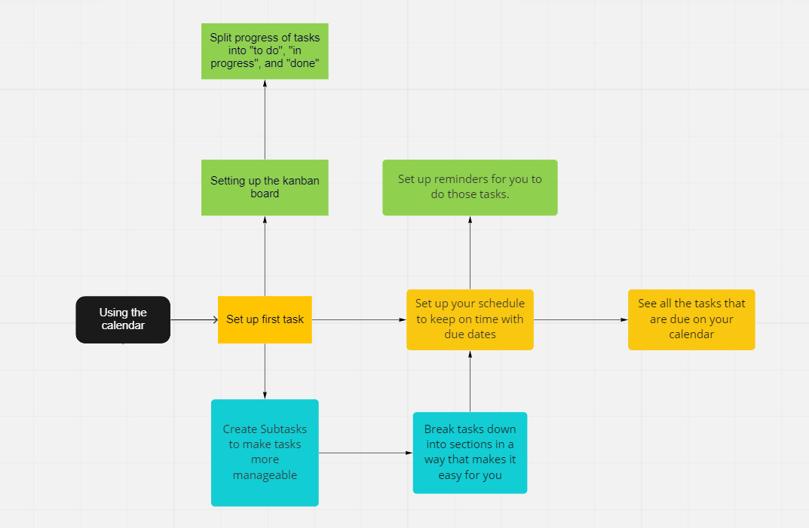

<https://miro.com/welcomeonboard/Y2hEWFhzakJpM1FSemswaTljZ09kd21pWmVyUHB0QTRvNzgyZmFXeFBuZTYzTHFXQjF4RzNWSUc1c3RNYVpIY3wzNDU4NzY0NTM0MDE1ODY3NjY5fDI=?share_link_id=791263105713>

**A series of short paragraphs describing YourApp.**

TimeWielder will be centered around a calendar view showing users their tasks for each day, week, or month depending on the view mode selected. All tasks will be set by the user in the calendar. In addition, users will have the option to create Kanban style boards to keep track of progress on assignments and projects. All tasks will be created in the calendar and automatically added to the kanban in the to do section.

In order to keep students on track, TimeWielder will prompt users to enable 'do not disturb' mode on their devices during scheduled assignment and study times.

**For each cause the app is addressing differently or better, a paragraph on how the app will do that.**

While motion is a fantastic application that smartly leverages AI to help users schedule their tasks, there are some benefits that TimeWielder will have over motion. Motion does not consider other notifications that might distract the user while TimeWielder will prompt the user to turn off notifications during work periods to help limit distractions. TimeWielder is also a free application which makes it much more accessible to those worried about finances.

Trello exclusively uses a Kanban board to track progress on projects, which isn't very convenient for planning your day. TimeWielder will use a calendar in addition to Kanban boards so the user can easily view their tasks for the day as well as track progress on projects.

Todoist is a solid application for those who are able to focus and stay on task. What TimeWielder will do better than Todoist is keeping users on task. TimeWielder will use push notifications to prompt users to stay on task and keep up with their due dates. TimeWielder also allows you to set aside certain times in your calendar to focus on doing your work where users will be prompted to turn off their notifications, so they can really fixate on completing their tasks promptly.

**User Stories**

As a user of TimeWielder, I want to be able to create an account in the system

As a user of TimeWielder, I want to be able to create a list of tasks and set due dates for them.

As a user of TimeWielder, I want to be able to connect an email or phone number to my account

As a user of TimeWielder, I want to be able to schedule blocks of time to work on specific tasks.

As a user of TimeWielder, I want to be able to change the due dates of tasks after I’ve created them.

As a user of TimeWielder, I want to be able to put exam times and dates into my calendar.

As a user of TimeWielder, I would like to be given recommended times to study for exams.

As a user of TimeWielder, I want to be able to set aside time to study for exams and have those times in my calendar.

As a user of TimeWielder, I would like to be able to mute all other notifications on my desktop while working on my tasks.

As a user of TimeWielder, I would like to be able to input all my assignments within 30 minutes of making an account.

As a user of TimeWielder, I should be able to see all scheduled assignments, tasks, etc. in a single clear calendar view.

As a user of TimeWielder, I would like to be able to switch between viewing schedules for individual days, weeks, and months.

As a user of TimeWielder, I would like to be able to sync my schedule to google calendar.

As a user of TimeWielder, I don't want to experience buffering longer than 5 seconds after any action.

As a user of TimeWielder, I would like to be able to input tasks and assignments within 2 minutes.

As a Windows 10/11 user, I must be able to use the app on all chromium browsers and firefox